NON TRADITIONAL MACHINING

Need for Non Traditional Machining
Conventional machining sufficed the requirement of the industries over the decades. But new exotic work materials as well as innovative geometric design of products and components were putting lot of pressure on capabilities of conventional machining processes to manufacture the components with desired tolerances economically. This led to the development and establishment of NTM processes in the industry as efficient and economic alternatives to conventional ones. With development in the NTM processes, currently there are often the first choice and not an alternative to conventional processes for certain technical requirements. The following examples are provided where NTM processes are preferred over the conventional machining process:

- Intricate shaped blind hole – e.g. square hole of 15 mmx15 mm with a depth of 30 mm
- Difficult to machine material – e.g. same example as above in Inconel, Ti-alloys or carbides.
- Low Stress Grinding – Electrochemical Grinding is preferred as compared to conventional grinding
- Deep hole with small hole diameter – e.g. φ 1.5 mm hole with l/d = 20
- Machining of composites.
Traditional Machining | Non Traditional Machining
1.Contact process ie Material removed by interference between tool and work  2. Machinability and MRR depends on hardness.  3. Further deburring operation is needed.  4. Relatively simple shapes. Complex shapes are either not possible or difficult to produce.  5. Tool wear is considerable.  6. Tool should be harder than work piece.  7. MRR is high.  8. Cutting force is large.  9. Stress can be induced in the work piece. | Non contact Process.  Not dependent on hardness.  Burr free operation.  Extremely complex shapes can be produced with relative ease.  No tool wear or negligible tool wear.  Soft tool can be used.  MRR is low.  Practically no cutting force.  No stress is induced in the work piece

Classification of Non Traditional Machining Processes

- Mechanical Processes
  - ⎯ Abrasive Jet Machining (AJM)
  - ⎯ Ultrasonic Machining (USM)
  - ⎯ Water Jet Machining (WJM)

- Electrochemical Processes
  - ⎯ Electrochemical Machining (ECM)
  - ⎯ Electro Chemical Grinding (ECG)

- Chemical Processes
  - ⎯ Chemical Milling (CHM)
  - ⎯ Photochemical Milling (PCM) etc.

- Electro-Thermal Processes
  - ⎯ Electro-discharge machining (EDM)
  - ⎯ Laser Jet Machining (LJM)
  - ⎯ Electron Beam Machining (EBM)
  - ⎯ Plasma Arc Machining (PAM)

Abrasive Jet Machining
Material removal takes place due to impingement of focus steam abrasive particles carried by a compressed gas. These abrasives are very fine. The abrasive jet can effectively machine hard and brittle materials like glass, silicon, and ceramics. Material removal takes place due to chipping action. Therefore softer materials like rubber and plastics are not processed effectively. The cutting action of abrasive particles is very cool as the carrier gas acts as coolant. The stream of abrasive particles leaves the nozzle at a velocity of the order of 300 m/s and strikes the surface of the w/p producing impact loading on it. Sever plastic deformation or micro cracks occur in the material due to the repeated impacts small chips of material loosened and a fresh surface get exposed to the jet.

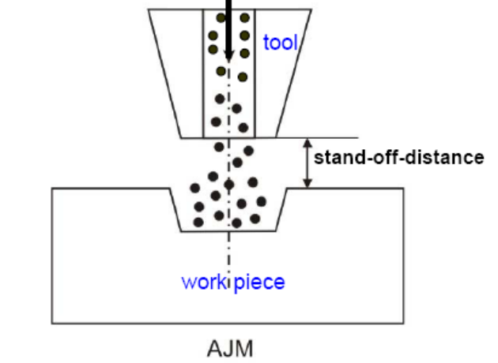
Abrasives: In most of the applications aluminum oxide is used as abrasives and silicon carbide used for very effective (faster cutting) when work piece is very hard. Particle size 10 to 50 microns give best result. The cutting performance depends on hardness strength particle size and shape of the abrasives. Dolomite is used for light cleaning and etching. Sodium carbonate is used for extra fine cleaning and glass beed are used for light polishing and fine deburring. In general large size abrasives used for rapid removal. Small ones used for good surface finish. Abrasives are not re-used as cutting action is degraded. Used abrasives will clog small orifices in the nozzle and abrasive powders must be kept dry.
Nozzle: To resist the abrasion and wear of nozzle, they are made of tungsten carbide and synthetic sapphire. The useful life of sapphire nozzle is 10 times that of tungsten carbide. Tungsten carbide nozzle is made circular, rectangular or square in cross section whereas sapphire nozzle is only round. Important parameter that affects machining is nozzle tip distance from work piece. As distance increases, MRR increases and beyond 12mm MRR decreases. This happens due to decrease in velocity of the abrasives due to drag. It also affects size of machined area.
Gas: carrier gas can be air nitrogen and carbon dioxide and never oxygen. Air must be filtered to remove water oil and other contaminators. Higher nozzle pressure results in rapid nozzle wear low pressure gives slow MRR.
Mask: Masks defining cutting area some times used to prevent stray cutting. Copper is good, all purpose masking material. Glass gives excellent definition but has a short life. Rubber has long life but poor definition.
Equipment:
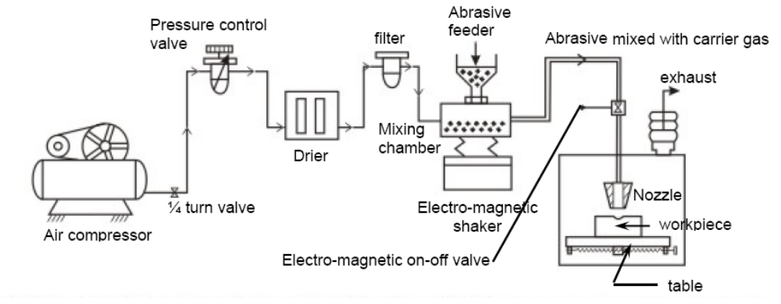
A schematic diagram of AJM is shown in figure. Dry and filtered gas is raised to a high pressure in the compressor. The pressurized air flows to the vibrating and mixing chamber containing abrasive powder. The mixture of pressurized air and abrasive particles then flows to nozzle. It then impinges on the work surface after shooting out of nozzle exit. The pressure regulator regulates the gas flow and its pressure. The feed rate of the abrasive powder is controlled by amplitude of vibration of mixing chamber. The movement of nozzle towards the workpiece is controlled by a cam mechanism or a pantograph.
The effect of some process parameters on MRR
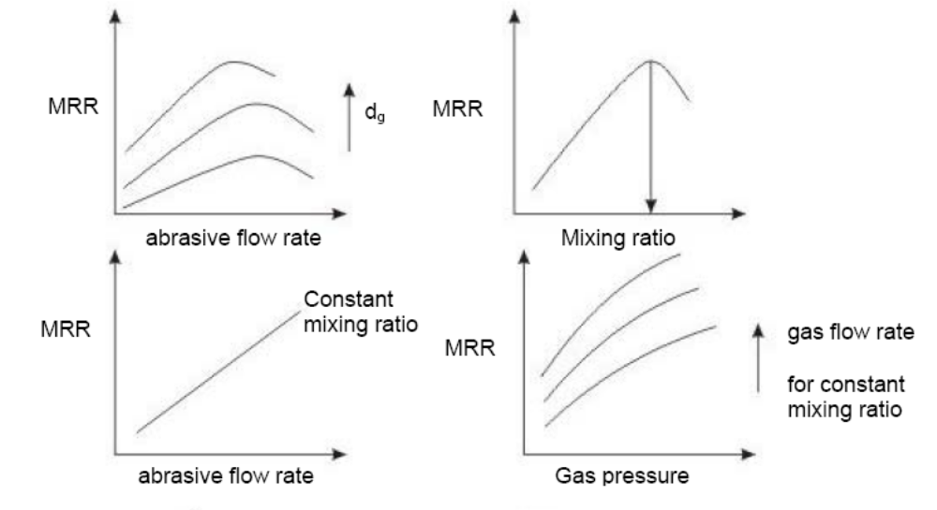

Applications:
- For drilling holes of intricate shapes in hard and brittle material.
- For machining fragile, brittle and heat sensitive materials
- AJM can be used for drilling, cutting, deburring, cleaning and etching.
- Micro-machining of brittle materials

Advantages:
- Free from chatter and vibration as no contact of tool with work piece.
- Provides cool, cutting actions and so has ability to cut delicate, heat sensitive materials without any damage.
- Capital cost is low and easy to maintain and operate.
- Process has the ability to cut intricate shaped holes.

Disadvantages:
- Low MRR.
- Stray cutting is unavoidable.
- Nozzle life is limited.
- Dust collection system is required.
- While machining soft material, abrasive may get embedded in work piece.

Water Jet Machining [WJM]

It utilizes a high velocity stream of water as cutting agent. At these velocities the Jet cuts through plastics, wood, ceramics, leather, titanium etc. here mechanism of metal removal is erosion. When high press water jet emerges out of a nozzle it attains high kinetic energy, when this high velocity jet strikes the work piece KE is converted into Pressure energy inducing high stress in the work material. When the induced stress exceeds the ultimate shear stress of the material rupture takes place.

Equipment is as similar that of AJM. In place of compressor here pump or intensifier to raise the pressure of water. Pressure normally used in the system are 1500 to 4000 N/m². From the pump the water goes to an accumulator. The accumulator helps in eliminating pulsation and also act as an energy reservoir such that cutting action may not be continuous. From the accumulator the water is lead to the nozzle through a high pressure thick stainless steel tubes. The material of the nozzle may be sintered diamond sapphire or tungsten carbide.

Advantage:

1) Energy transfer media(water) is cheap, non toxic and easy to dispose.
2) Work area remains clean and dust free.
3) Process is safe, low maintenance and operating cost is low as it has no moving parts. 4) Intricate contour can be cut.
5) There is no thermal damage.

Disadvantage:
- Initial cost is high.
- Hard material can not be cut.
- Lack of suitable pumping devices.
- Noisy.

Ultrasonic Machining
It is a machining process there is no physical contact b/w tool and w/p. The gap b/w d tool n w/p is about 0.25mm.The tool tip is vibrated at the ultrasonic frequency to the order of 20-30Khz.
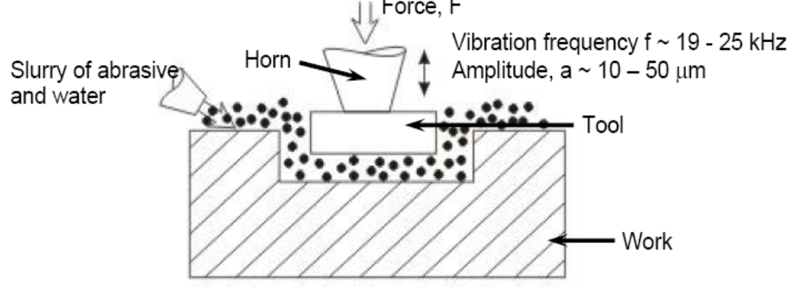
A ferromagnetic material like Fe-Al₂, Fe-Co or Ni is used to make transducer wound with an excitation coil which converts electrical energy into mechanical vibrations with ultrasonic frequency. Excitation Coil is energized or excited by the alternating voltage supply of ultrasonic frequency. Due to magnetostriction effect the transducer will start vibrating in longitudinal direction at ultrasonic frequency. The transducer is connected to the transducer cone by silver soldering. The tool cone is fixed mechanically and amplifies and focuses the mechanical energy produced by the transducer and imparts this to the w/p in such way that energy utilization is optimum. The tool tip which is replica of the work to be produced is fixed mechanically to the tool cone and also vibrate at the same frequency. The tool material is softer than work material. Generally used material are alloy steel copper brass stainless steel. An abrasive slurry usually the mixture of abrasive grains such as SiC, ceramics etc. and water or kerosene of definite proportions is pumped to tool work interface. The vibrating tool tip will throw abrasive grains on to the w/p at high velocity when sharp edges of the grains with the work surface material will eroded forming the chip and tool tip will reproduce on it. Then chips are carried away by the carrier fluid. It also helpful in cooling the work piece. The abrasive slurry has to be changed frequently to improve the effectiveness because when abrasive hit the surface they loose their sharpness.
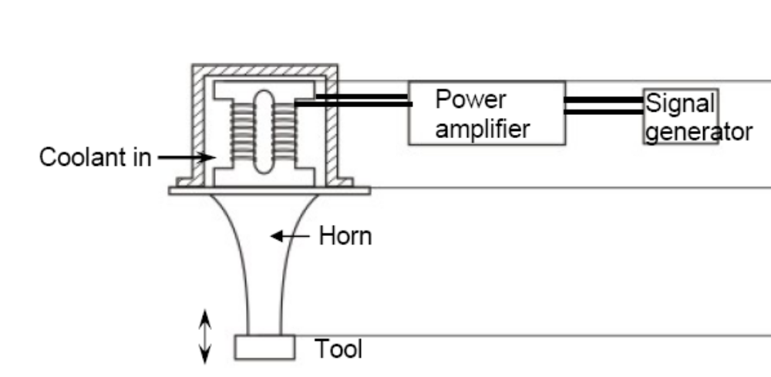

As the material is removed from work piece the gap between the tool and the work increases and hence tool feed mechanism which is operated either mechanically or hydraulically is used to keep the distance between tool and work constant. About 60%-70% of total electrical energy is supplied to the transducer coil is desipated asheat and hence proper cooling arrangements is made to keep transducer cool.

Process Parameters and their Effects.
The process parameters which govern the ultrasonic machining process have been identified and the same are listed below along with material parameters
- • Amplitude of vibration (a_{o}) – 15 – 50 μm
- • Frequency of vibration (f) – 19 – 25 kHz
- • Feed force (F) – related to tool dimensions
- • Feed pressure (p)
- • Abrasive size – 15 μm – 150 μm
- • Abrasive material – Al₂O₃
  - - SiC
  - - B₄C
  - - Boronsilicarbide
  - - Diamond
  - • Flow strength of work material
  - • Flow strength of the tool material
  - • Contact area of the tool – A
  - • Volume concentration of abrasive in water slurry – C

The effect of parameters on MRR.

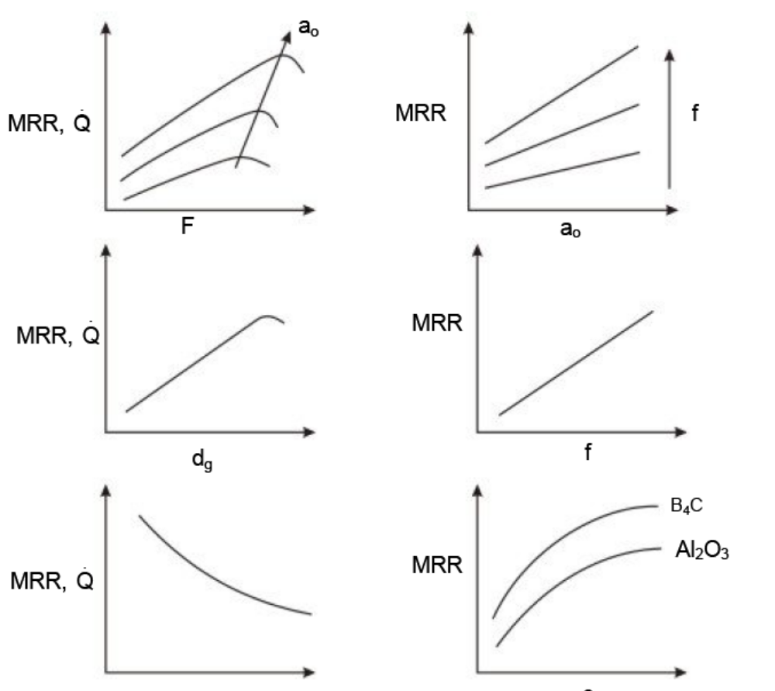

Advantages:
- Distortion less
- No thermal effect
- Burrless
- Machines non conductor materials also.
Disadvantages:
- Low MRR
- Tool wear is more
- Not economical for ductile material
APPLICATIONS:
- In drilling, milling, machining glass, cutting threads, in medical field (dentistry).
- Used for machining hard and brittle metallic alloys, semiconductors, glass, ceramics, carbides etc.
- Used for machining round, square, irregular shaped holes and surface impressions.
- Machining, wire drawing, punching or small blanking dies.

Electrochemical Machining [ECM]

Removal of metal by controlled dissolution of the anode of an electrolytic cell. Suited to metals and alloys which are difficult or impossible to machine by conventional machining process. This is based on Michael faradays laws of electrolysis requiring basically two electrodes an electrolyte a gap and a source of dc power. The cathode is tool shaped. The work piece is connected to +ve supply. The tool of cathode is connected to –ve terminal, is advanced towards anode work piece through the electrolyte that completes the electrical circuit between anode and cathode. Metal is then removed from the work piece through electrical action and the cathode shape is reproduced on the work piece. Electrolyte bath is pumped at high pressure through the gap between the work piece and tool must be circulated at rate sufficiently high to conduct current between them and to carry heat. The electrolysis process that takes place at cathode liberates hydroxyl ions which combine with metal ions and per hydrogen. The process continues and the cathode reproduces its shape in work piece. The tool doesn’t contact the work, producing no friction, wear and tear.

Process

During ECM, there will be reactions occurring at the electrodes i.e. at the anode or workpiece and at the cathode or the tool along with within the electrolyte.
Let us take an example of machining of low carbon steel which is primarily a ferrous alloy mainly containing iron. For electrochemical machining of steel, generally a neutral salt solution of sodium chloride (NaCl) is taken as the electrolyte. The electrolyte and water undergoes ionic dissociation as shown below as potential difference is applied.

NaCl ↔ Na⁺ + Cl⁻
H₂O H↔⁺ + (OH)⁻

As the potential difference is applied between the work piece (anode) and the tool (cathode), the positive ions move towards the tool and negative ions move towards the workpiece.
Thus the hydrogen ions will take away electrons from the cathode (tool) and from hydrogen gas as:
2H⁺ + 2e⁻ = H₂↑ at cathode
Similarly, the iron atoms will come out of the anode (work piece) as:
Fe = Fe⁺ ⁺ + 2e⁻
Within the electrolyte iron ions would combine with chloride ions to form iron chloride and similarly sodium ions would combine with hydroxyl ions to form sodium hydroxide
Na⁺ + OH⁻ = NaOH
In practice FeCl₂ and Fe(OH)₂ would form and get precipitated in the form of sludge. In this manner it can be noted that the work piece gets gradually machined and gets precipitated as the sludge. Moreover there is not coating on the tool, only hydrogen gas evolves at the tool or cathode. Fig. Below depicts the electro-chemical reactions schematically. As the material removal takes place due to atomic level dissociation, the machined surface is of excellent surface finish and stress free.

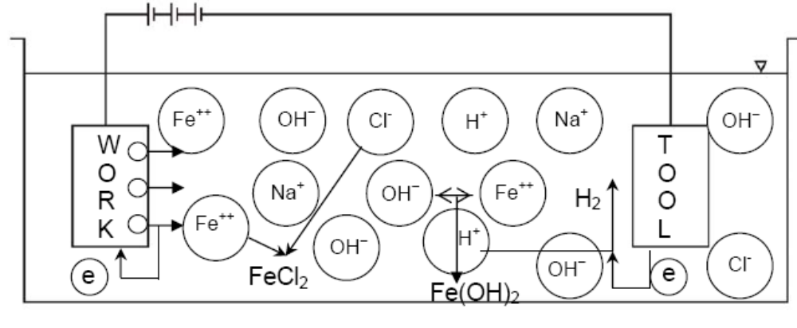

Equipment

The electrochemical machining system has the following modules:
- • Power supply
- • Electrolyte filtration and delivery system
- • Tool feed system
- • Working tank

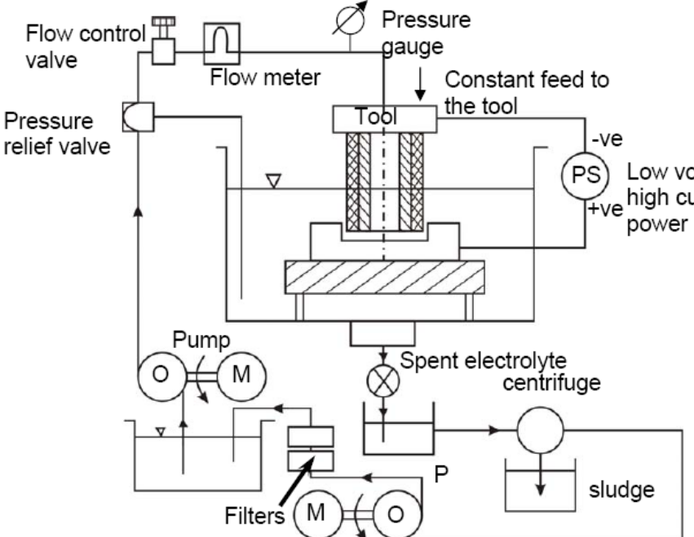

Process Parameters

Power Supply
Type direct current
Voltage 2 to 35 V
Current 50 to 40,000 A
Current density 0.1 A/mm² to 5 A/mm²
Electrolyte
Material NaCl NaNO₃ Sodium nitrate, potassium chloride, sodium hydroxide Temperature 20ºC – 50ºC
Flow rate 20 lpm per 100 A current
Pressure 0.5 to 20 bar
Dilution 100 g/l to 500 g/l
Working gap 0.1 mm to 2 mm
Overcut 0.2 mm to 3 mm
Feed rate 0.5 mm/min to 15 mm/min
Electrode material Copper, brass, bronze
Surface roughness, R_{a} 0.2 to 1

Advantages:

- There is no cutting forces therefore clamping is not required except for controlled motion of the work piece.
- There is no heat affected zone.
- Very accurate.
- Relatively fast
- Can machine harder metals than the tool.

Disadvantages

- More expensive than conventional machining.
- Need more area for installation.
- Electrolytes may destroy the equipment.
- Not environmentally friendly (sludge and other waste)
- High energy consumption.
- Material has to be electrically conductive.

APPLICATIONS:
  - Machining hard heat resistant alloys.
  - Cutting cavity in forging dies, for drilling holes,
  - Machining complex structure.
Electrochemical grinding [ECG]

The work is machined by the combined action of electrochemical effect and conventional grinding operation. The majority of the metal removal from electrolytic action. The tool electrode is a rotating metal diamond or aluminum oxide wheel and it acts as cathode. The work acts as anode and hence current flow between work and wheel. A constant gap of abut 0.25mm is maintained between work and wheel and through this gap an essentially neutral electrolyte is circulated. The Electrolyte is carried past the work surfaces at high speed by the rotary action of the grinding wheel. The grinding wheel runs at speeds o 900-1800 rpm.
The important functions of abrasive particles are:-

- It act as insulators to maintain a small gap between wheel and work piece.
- They remove electrolysis products from the work area.
- To cut chips if the wheel should continue the work particularly in the event of power failure.

In this process 90% of the metal is removed by electrolytic actions and only about 10% by abrasive grinding.

Electrolyte; aqueous solution o sodium silicate, sodium nitrate borax.

Grinding Wheel :
Abrasives – Aluminium oxide, dimond.
Size: 60-80 mesh grid.
Bonding agents: copper, brass and nickel.

Equipment:

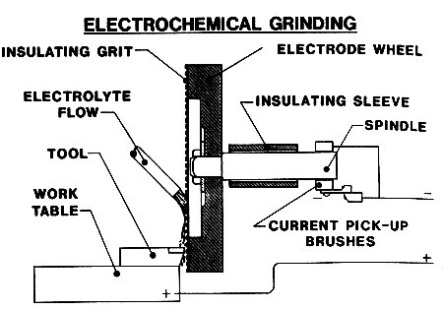

Advantages:-
- Tool wear is negligible which greatly increases the life of the grinding wheel.
- It produces smoother surface and doesn’t produce surface stresses and distortion as in conventional grinding.
- It is much more rapid.
Limitations: Initial cost is high,
- Non conducting hard materials can’t be machined,
- Most electrolyte in corrosive in nature.
Applications: Grinding following materials.
    - Carbide cutting tools.
    - Refractory metals.
    - High strength steels
    - Nickel and cobolt based alloys.

COMPARISON BETWEEN GRINDING ANE ECG
Grinding | ECG
- Grinding is due to mechanical abrasion (contact process)  - Insulated bonding material to manufacture grinding wheel.  - Considerable tool wear.  - Reasonable surface finish.  - Grinding is slow process  - Several passes are required.  - Coolants are used.  - Can be used for conducting and non conducting materials.  - Work is subjected to mechanical and thermal stresses. | Grinding is due to electrolytic action(90%) and abrasion(10%).  Metal bonded G W acts as conductor of electricity.  Negligible tool wear (ten times more)  Excellent surface finish.  ECG is more rapid.  Single pass grinding.  Electrolyte is used.  Only for conducting materials.  Free from any kind of stresses.
Chemical Machining

Chemical machining is controlled etching process in which metal is removed to produce complex parts. This process is relatively simple, consists first of thoroughly cleaning the part to be etched. It is then prepared in the etching process by making those areas not be affected with a chemically resistant coating. This part is then submerged in hot alkaline solutions where the metal in the unprotected area is eroded. The amount of metal removal depends mainly on the that the part is in the hot solution. Finally the part is neutralized and the masking material is removed.

Masking Masking is applied by either a dip or airless spray techniques. Coatings are then air used or packed to immerse the etchant resistance of the mask. The material being used as maskant should have the ability to adhere to all portion of the metal part. The maskant should have ability to be easily peeled away after the process. The commonly used maskants include plastics and elastomers. Various elastomers used as a maskants include acrylonitryl rubber, butyl rubber and neoprene. Plastics such as PVC, polystyrene poly ethylene are also used as maskants.

Etchants Ferric chloride is used on several metals such as Al2, cu, and steel, lead, mild steel, sodium hydroxide is commonly used as aluminum alloys at a temperature of 50 degree Celsius. Nitric acid is used for zinc and magnesium. Hydrogen fluoride is used for titanium and silicon.

One unusual problem involved in chemical milling is that of under cutting. As the chemical dissolves the bottom hole, it also attacks side of the hole. The rate at which this takes place is called etch factor.It must be included in design.

Photo Chemical Machining (PCM)
PCM is a material removal process using chemicals (etchants) to produce high precision parts. This process is also known as Photo Etching, Chemical Blanking and Photo Chemical Milling.

- Procedure of PCM Artwork- generate design using CAD systems, then plot it using a high precision laser plotter to produce photo-tool.
- Chemically clean the metal surface.
- Coat both sides of the plate with photoresist. (photoresist is a polymer that adheres to the metal when exposed to UV light).
- Expose plate and photo-tool to ensure image transfer.
- Spray metal with etchant or dip it in hot acidic solution to etch all material other than part covered with photoresist (1-15 min.).
- Rinse the plate to ensure photoresist and etchant removal.

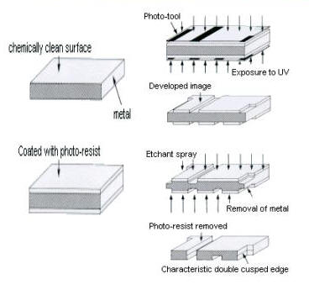

Immersion Machining
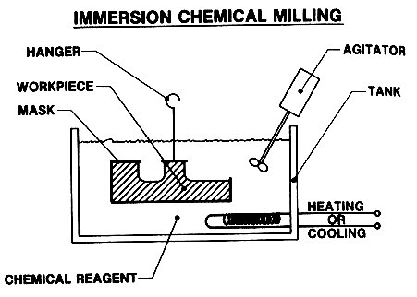

- Masking attached to areas not desired to be machined
- Entire part immersed in etchant chemical
- Can be repeated until correct part created

Advantages
- Low Tooling Cost- all tooling is produced by CAD systems at a low cost with a short creation time.
- Low Modification Cost- short runs are possible at a low cost, thus, design can be easily modified.
- Burr and Stress Free.
- Complex Designs.
Disadvantages
  - Expensive equipment and tools
  - Electrolytic solution is hazardous to environment as well as equipment
Applications:
- Producing printed circuit boards.
- Aerospace industry to process shallow pockets on wings and production of special surface configuration of skin sections.
- Production of parabolic radar reflectors, heat exchanger etc.

Electric Discharge Machining

It is also known as spark erosion or spark machining. It is a process of metal removal based on the principle of erosion of metals by an interrupted electric spark discharge between the electrode tool (cathode) and the work (anode). In EDM process electric energy is used to cut the material to final shape and size. Efforts are made to utilize all the energy by applying it at the exact spot where the operation to be carried out. No complicated fixtures are needed for holding the job and even very thin jobs can be machined to the desired dimensions and shape. All the operating is carried out in a single setup. This process may be applied to machine steels, supper alloys, refractories etc.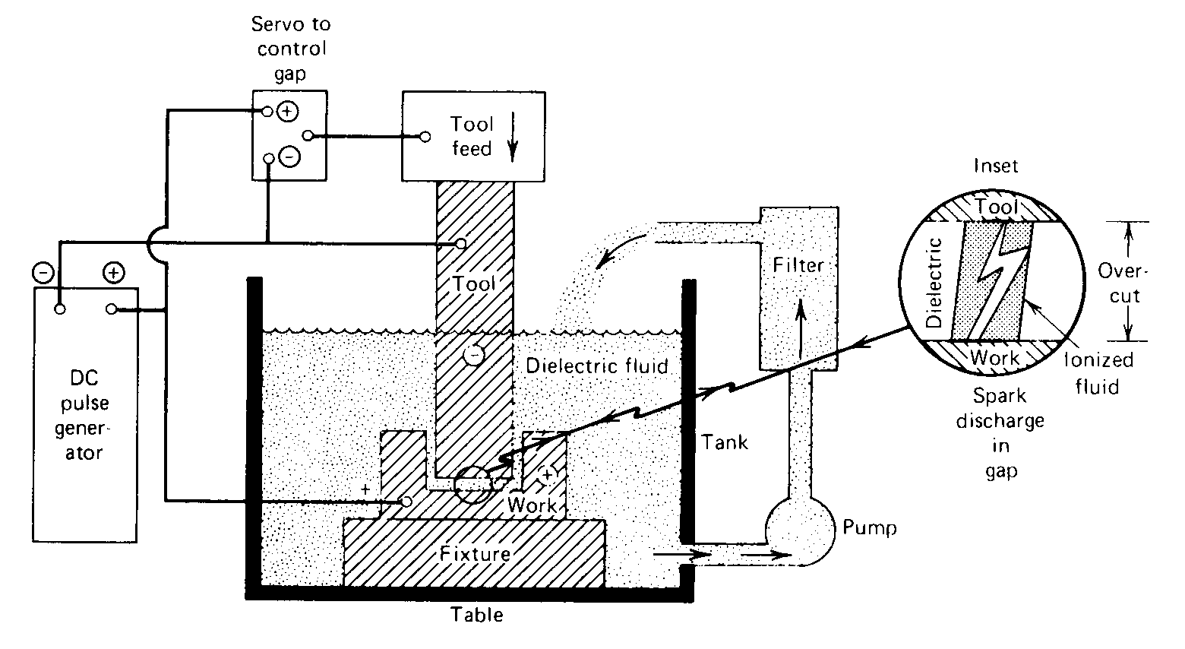

When a difference of potential is applied between two conductors immersed in a dielectric fluid, the fluid will ionize if the potential difference reaches a high enough valve and spark will occur. If the potential difference is maintained then the spark will develop into an arc, otherwise spark extinguishes. The control erosion of metal is achieved by the rapidly recurring spark discharge produced between two electrodes one tool and other work end spark impinging against the surface of the work piece which must be an electrically conducting body. A suitable gap known as spark gap is maintained between tool and the work by a servo motor which feeds the tool downward towards the work piece. The MRR depends on spark gap maintained. If both the electrodes are made of same material it has been found that the greatest erosion takes place upon the positive electrode. To remove maximum metal and have minimum wear of tool, the tool is made the cathode and work piece the anode. The two electrodes are separated by a dielectric fluid medium such as paraffin or transformer oil which is pumped through the tool or work piece at a pressure of 2 kgf/cm^{2.} The current may vary from 0.5 to 400amp at 40 to 300 V DC. Pulse duration 2 to 2000.The moment the spark occurs; sufficient pressure is developed between the work and tool. The repetitive sparks releases their energy in the form of local heat as a result of which local temp of around 10000C is reached at the spot hit by electrons and at such high pressure and temp, the metal is melted and some of vaporized and some particles are carried away by dielectric fliid circulated around it, forming a crater around the work piece.

Spark Generator: supplies adequate voltage to initiate and maintain the discharge current intensity and discharge duration and controlling the recurring rhythm of the discharge.

Electrode Material

Electrode material should be such that it would not undergo much tool wear when it is impinged by positive ions. Thus the localized temperature rise has to be less by tailoring or properly choosing its properties or even when temperature increases, there would be less melting. Further, the tool should be easily workable as intricate shaped geometric features are machined in EDM. Thus the basic characteristics of electrode materials are:
- • High electrical conductivity – electrons are cold emitted more easily and there is less bulk electrical heating
- • High thermal conductivity – for the same heat load, the local temperature rise would be less due to faster heat conducted to the bulk of the tool and thus less tool wear
- • Higher density – for the same heat load and same tool wear by weight there would be less volume removal or tool wear and thus less dimensional loss or inaccuracy
- • High melting point – high melting point leads to less tool wear due to less tool material melting for the same heat load
- • Easy manufacturability
- • Cost – cheap

The followings are the different electrode materials which are used commonly in the industry:
- • Graphite
- • Electrolytic oxygen free copper
- • Tellurium copper – 99% Cu + 0.5% tellurium
- • Brass

Dielectric Fluid: Essential requirements:-remain electrically non conductive until required breakdown voltage is desired. –Breakdown electrically in the shortest possible time once the breakdown voltage has been reached – deionise the spark after the discharge has occurred. – Provide effective cooling – should be cheap and good degree of fluidity.

Advantages: -It can be applied to all electrically conducting metals & alloys irrespective of their melting point, hardness, toughness and brittleness.
Any complicated shape that can be made by fabricating of tool can be reproduced on the work piece.
The machining faster than conventional machining.
It can be employed for extremely hard material.
No residual stresses.
Disadvantages:
Excessive tool wear.
High specific power consumption.
Machining heats the work piece considerably.

APPLICATIONS: Manufacture of process tools, extrusion dies, forging dies and moulds. – drill the holes in hardened points like nozzle.

ECM | EDM
- Tool is the female mating image of the cavity to be produced  - Continuous power supply  - Electrolytes used  - Complete submersion not necessary  - Absolutely free from thermal stresses | - No specific tool shape  - Intermittent power supply  - Dielectric medium used  - Work piece submerged in the dielectric fluid  - Thermal stresses may be developed

Laser Beam Machining

Laser is an electro magnetic radiation. It produces monochromatic light which is in the form of an almost collimated beam that can be focused optically on to a very small spots. The word laser stands for Light Amplification Stimulated Emission of Radiation.
The principle of laser can be explained as follows. Let us consider the atoms of ruby crystal at ground state. When a quantum of energy from a light source is made to fall on the medium, it causes absorption of radiation by the atoms and this result in electrons of the atoms to jump to higher energy levels. Atoms in upper energy level are said to be in excited state. The atom in excited state immediately begins to drop to the meta-stable state and they thus emit photons at random before they fall to original energy level. This is called spontaneous emission which is extremely rapid and is a chain reaction, also called lasing action.

Nucleus
Electron
Ground State
Excited State
Orbits
Photon
Electron is energized to the excited state
Electron relaxes to ground state and photon is produced

Most important part of the laser apparatus is the laser crystal which is mostly ruby (aluminium oxide into which 0.05% of chromium is added) the crystal rods are usually round and the surfaces are made reflecting mirrors. A flash lamp filled with xenon, argon or krypton gas. The lamp is placed close to a crystal rod inside a highly reflecting cylinder which directs the light from the flash lamp into the rod; so that as much energy as possible can be absorbed by laser material. The chromium atoms in ruby are excited to high energy levels emitting photons and energy. The ruby rod becomes less efficient at high temperature and is continuously cooled with air, water or liquid nitrogen. 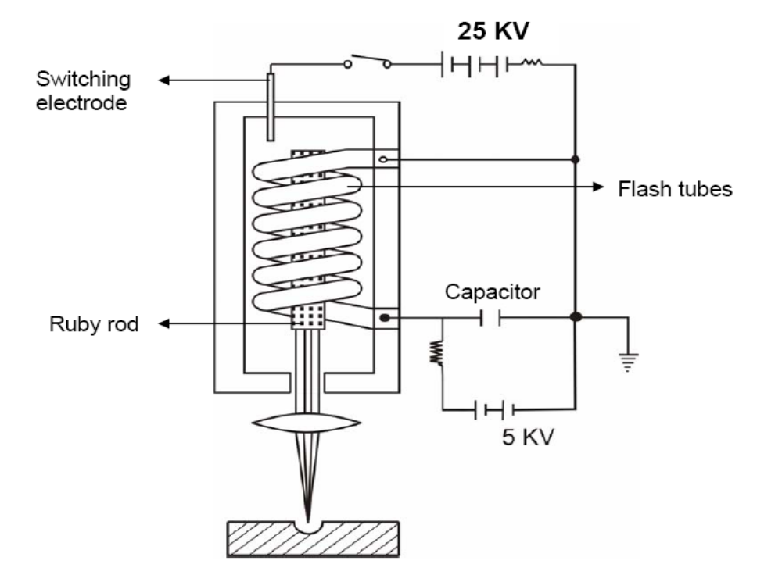

The work piece to be cut is placed in aluminum work table. The laser head travels over the work piece and an operator usually inspects the cut while manually operating the controls. By focusing a laser beam on a spot, energy of several joules lasting for a minute fraction of seconds. Laser can provide enough heat to melt and vaporize any known material. Mechanism by which laser beam removes material involves combination of melting and evaporation processes.

Accuracy: For drilling accuracy is within ±0.2mm and for cutting ±0.1mm.

Advantages: Machining of any metal and non metal is possible - drilling and cutting of areas not readily accessible are possible - heat affected zone is small because of collimated beam – extremely small holes can be machined – there is no wear – rubber and plastics can also be machined.

Limitations: Cannot be used to cut metals that have high heat conductivity - Actual efficiency is extremely low – process is limited to thin sheets – low MRR – machine holes are not round and strong – cost is high – life of flash lamp is short.

Application: Machining of small holes and complex profile of hard materials and ceramics – partial cutting and engraving, steel metal trimming, blanking and resistor trimming – in mass micro-machining production.

Electron Beam Machining [EBM]

In EBM electrons emitted by a hot surface and accelerated by a voltage of 10-50kv are focused to a very small area on the work piece. This stream of high energy electron posses a very high energy density of the order of 10⁴kw/mm2 and when this narrow stream strikes the work piece the KE of the electrons is converted to powerful heat energy which is quite sufficient to melt and vaporize any material. Even though the electron can penetrate metals to a depth only few atomic layers of the electron beams can metal to a depth of 25mm or more. These electron beams are focused on the work piece by electrostatic or electromagnetic lens. It is done in a high vacuum chamber to eliminate the scattering of the electron beam as it contacts the gas molecules on work piece. 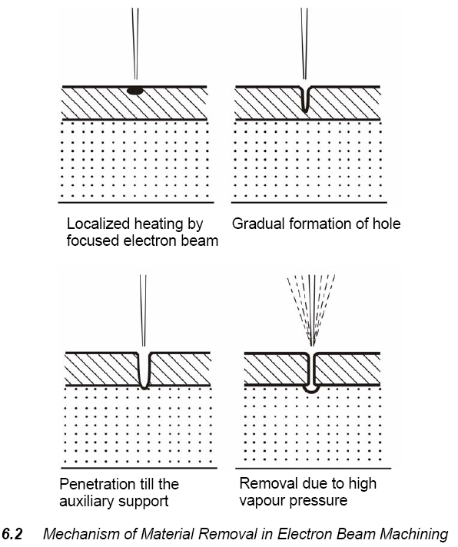

Equipment:

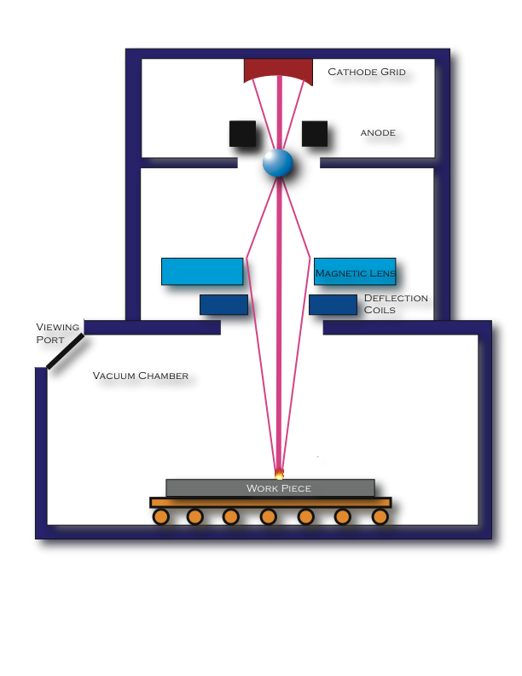

Process parameters

- Material removal by - melting, vaporization
- Medium - Vacuum
- Tool - beam of electrons moving at very high velocity
- Maximum MRR = 10 mm3/min
- Specific Power Consumption = 450W/mm3/min
- Critical Parameters - accelerating voltage, beam current, beam diameter, work speed, melting temperature
- Materials Application - all materials
- Shape Application - drilling fine holes, cutting contours in sheets, cutting narrow slots
- Limitations - very high specific energy consumption, necessity of vacuum, expensive machine.

Applications:
- Micro machining operations on thin metals including drilling perforating and scribing the engraving.
- It is used to manufacture field emission cathodes, integrated circuits and computer memories.
- Useful for materials with high melting points and low thermal conductivity.

Advantages:
- High accuracy.
- High rate of production.
- Metals and non metals can be machined.
- No chemical and thermal distinction.

Limitation:
- MRR is low.
- Method is quite difficult.
- Equipment is expensive.
- Holes produced in materials of greater thickness is tapered.

Plasma Arc Machining

We know all gases burning at high temperature are ionized and becomes electrically conductive. In PAM the gases are ionized by placing an arc across the path of gas flow. The gas molecules get dissociated causing large amount of thermal energy to be liberated, generating a temperature of the order of 16500c which is then utilized in removing metal by melting and vaporization.
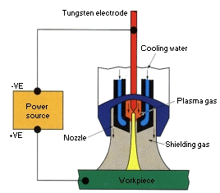

An arc is struck between tungsten cathode and the water cooled copper anode. An inert gas such as argon is passed through a small chamber in which arc is maintained. As the gas flows out of the nozzle, it is heated and gets ionized by the arc and forms a moving plasma flame. The cathode is eroded by a high spark temp and must be adjusted. Due to exponentially high temp generated, the plasma nozzle must be maintained in a constant state of cooling generally by water flow through the torch.

Transferred Arc and Non transferred arc

A plasma jet can be operated in the transferred mode, where the electric current flows between the plasma torch electrode (cathode) and the work piece (anode).In the transferred arc method , the arc creates the greatest amount of heat and is used when cutting . This method is used in case of ferrous, conductive metals.

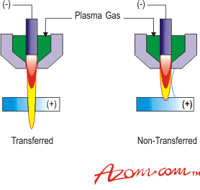

In the non-transferred mode the electric current flows between the electrode and the torch nozzle. Allows plastics and other nonconductive materials to be cut. This is method is generally not preferred in industries because transferred arc method is much efficient and maximum amount of heat generated is used in case of transferred arc.

Gases: Air, nitrogen, oxygen, argon, hydrogen.
Oxygen & carbon steel (30 to 35mm thick).
Nitrogen & air (any metal up to 50mm thick).
Argon & hydrogen (non ferrous metal up to 150mm thick)
.
Power Sources: High voltage DC power source
Current 20 to 100amp and voltage- 20 to 40.

Advantages:
High speed cutting. Plasma cutting is 3 to 8 times faster than oxy acetylene cutting.
Smooth cut free from contaminants are obtained.
Profile cutting of stainless steel can be easily done.

Limitation:
There’ll be heat affected zone.
Well attached drops on the under side of the cut can be a problem.
Plasma is expensive.

Applications: Welding of titanium, stainless steel and metal spraying.

Comparison between traditional and Non traditional Machining

Traditional | Non traditional
Material is removed by interference between tool and work (contact process) | Non contact process.
Mach inability and MRR depends on hardness. | Not depended on hardness
Further deburring operation is needed | Burr free machining
Relatively simple shapes. Complex shapes are either not possible or difficult to produce. | Extremely complex shapes can be produced with relatively ease.
Tool wear is considerable | No tool wear or negligible tool wear.
Tool should be harder than work piece. | Soft tool can be used.
MRR is high. | MRR is low.
Cutting force is .large | Practically no cutting force.
Stresses are induced in the work piece. | No stress is included in the work piece.

